**Заметки**

**Программный код:**

**Activity_main:**

<?xml version="1.0" encoding="utf-8"?>  
<androidx.constraintlayout.widget.ConstraintLayout xmlns:android="http://schemas.android.com/apk/res/android"  
 xmlns:app="http://schemas.android.com/apk/res-auto"  
 xmlns:tools="http://schemas.android.com/tools"  
 android:layout_width="match_parent"  
 android:layout_height="match_parent"  
 tools:context=".MainActivity">  
  
 <ScrollView  
 android:layout_width="match_parent"  
 android:layout_height="match_parent"  
 android:layout_marginStart="10dp"  
 android:layout_marginTop="10dp"  
 android:layout_marginEnd="10dp"  
 android:layout_marginBottom="80dp">  
  
 <LinearLayout  
 android:id="@+id/parrent"  
 android:layout_width="match_parent"  
 android:layout_height="wrap_content"  
 android:orientation="vertical">  
  
 <LinearLayout  
 android:layout_width="match_parent"  
 android:layout_height="match_parent"  
 android:orientation="horizontal">  
  
 <ImageView  
 android:id="@+id/imageView2"  
 android:layout_width="50dp"  
 android:layout_height="50dp"  
 android:padding="10dp"  
 tools:srcCompat="@drawable/_f4c1" />  
  
 <LinearLayout  
 android:layout_width="match_parent"  
 android:layout_height="match_parent"  
 android:orientation="vertical">  
  
 <TextView  
 android:id="@+id/textView"  
 android:layout_width="match_parent"  
 android:layout_height="wrap_content"  
 android:text="Название файла"  
 android:textColor="#000000"  
 android:textSize="18sp" />  
  
 <TextView  
 android:id="@+id/textView2"  
 android:layout_width="match_parent"  
 android:layout_height="wrap_content"  
 android:text="Дата создания" />  
 </LinearLayout>  
 </LinearLayout>  
 </LinearLayout>  
 </ScrollView>  
  
 <Button  
 android:id="@+id/button"  
 android:layout_width="312dp"  
 android:layout_height="70dp"  
 android:text="Создать"  
 android:onClick="OpenNote"  
 app:layout_constraintEnd_toEndOf="parent"  
 app:layout_constraintStart_toStartOf="parent"  
 app:toggleCheckedStateOnClick="false"  
 tools:ignore="MissingConstraints"  
 tools:layout_editor_absoluteY="529dp" />  
  
  
</androidx.constraintlayout.widget.ConstraintLayout>

**Activity_note:**

<?xml version="1.0" encoding="utf-8"?>  
<androidx.constraintlayout.widget.ConstraintLayout xmlns:android="http://schemas.android.com/apk/res/android"  
 xmlns:app="http://schemas.android.com/apk/res-auto"  
 xmlns:tools="http://schemas.android.com/tools"  
 android:layout_width="match_parent"  
 android:layout_height="match_parent"  
 android:background="@color/purple_200"  
 tools:context=".NoteActivity">  
  
 <EditText  
 android:id="@+id/editTextTextPersonName"  
 android:layout_width="358dp"  
 android:layout_height="41dp"  
 android:background="#FFFFFF"  
 android:backgroundTint="#FFFFFF"  
 android:ems="10"  
 android:inputType="textPersonName"  
 android:paddingLeft="10dp"  
 android:paddingRight="10dp"  
 app:layout_constraintEnd_toEndOf="parent"  
 app:layout_constraintStart_toStartOf="parent"  
 tools:ignore="MissingConstraints"  
 tools:layout_editor_absoluteY="36dp" />  
  
 <MultiAutoCompleteTextView  
 android:id="@+id/multiAutoCompleteTextView"  
 android:layout_width="361dp"  
 android:layout_height="531dp"  
 android:background="#FFFFFF"  
 android:backgroundTint="#FFFFFF"  
 android:textAllCaps="false"  
 app:layout_constraintEnd_toEndOf="parent"  
 app:layout_constraintStart_toStartOf="parent"  
 tools:ignore="MissingConstraints"  
 tools:layout_editor_absoluteY="83dp" />  
  
 <Button  
 android:id="@+id/button2"  
 android:layout_width="185dp"  
 android:layout_height="50dp"  
 android:background="@color/white"  
 android:backgroundTint="#808080"  
 android:fallbackLineSpacing="false"  
 android:text="Создать"  
 android:onClick="AddNote"  
 android:textColor="#FFFBFB"  
 app:icon="@color/white"  
 app:layout_constraintEnd_toEndOf="parent"  
 app:layout_constraintStart_toStartOf="parent"  
 tools:ignore="MissingConstraints,OnClick"  
 tools:layout_editor_absoluteY="638dp" />  
  
  
</androidx.constraintlayout.widget.ConstraintLayout>

**NoteActivity.java:**

package com.example.zametki;  
  
import androidx.appcompat.app.AppCompatActivity;  
  
import android.os.Bundle;  
  
public class NoteActivity extends AppCompatActivity {  
  
 @Override  
 protected void onCreate(Bundle savedInstanceState) {  
 super.onCreate(savedInstanceState);  
 setContentView(R.layout.*activity_note*);  
 }  
}

**MainActivity.java:**

package com.example.zametki;  
  
import androidx.appcompat.app.AppCompatActivity;  
  
import android.graphics.Color;  
import android.os.Bundle;  
import android.view.View;  
import android.widget.EditText;  
import android.widget.ImageView;  
import android.widget.LinearLayout;  
import android.widget.MultiAutoCompleteTextView;  
import android.widget.RelativeLayout;  
import android.widget.TextView;  
  
import java.text.SimpleDateFormat;  
import java.util.ArrayList;  
import java.util.Date;  
import java.util.List;  
  
public class MainActivity extends AppCompatActivity {  
  
 @Override  
 protected void onCreate(Bundle savedInstanceState) {  
 super.onCreate(savedInstanceState);  
 setContentView(R.layout.*activity_main*);  
 }  
  
 public void OpenNote(View view){  
 setContentView(R.layout.*activity_note*);  
 }  
 public class notes{  
 public String name;  
 public String text;  
 public String date;  
 }  
 public List<notes> list_nites = new ArrayList<>();  
  
 public void AddNote(View view){  
 notes new_notes = new notes();  
  
 EditText e_name = findViewById(R.id.*editTextTextPersonName*);  
 new_notes.name = e_name.getText().toString();  
  
 MultiAutoCompleteTextView e_text = findViewById(R.id.*multiAutoCompleteTextView*);  
 new_notes.date = e_text.getText().toString();  
  
 Date dateMow = new Date();  
 SimpleDateFormat formatForDateNow = new SimpleDateFormat("yyyy.MM.dd");  
 new_notes.date = formatForDateNow.format(dateMow);  
  
 list_nites.add(new_notes);  
 setContentView(R.layout.*activity_main*);  
 onLoad();  
  
 }  
 public void onLoad(){  
 LinearLayout parrent = findViewById(R.id.*parrent*);  
  
 System.*out*.print(list_nites.size());  
 for(int i=0; i< list_nites.size(); i++){  
  
 LinearLayout ll = new LinearLayout(this);  
 ll.setOrientation(LinearLayout.*HORIZONTAL*);  
 RelativeLayout.LayoutParams params = new RelativeLayout.LayoutParams(  
 RelativeLayout.LayoutParams.*MATCH_PARENT*,  
 RelativeLayout.LayoutParams.*MATCH_PARENT* );  
 ll.setLayoutParams(params);  
 ll.setTag(i);  
 ll.setOnClickListener(this::OpenNote);  
  
 ImageView iv = new ImageView(this);  
 iv.setImageResource(R.drawable.*_f4c1*);  
 LinearLayout.LayoutParams layoutParams = new LinearLayout.LayoutParams(150,150);  
 iv.setLayoutParams(layoutParams);  
 iv.setPadding(20,20,20,20);  
  
 LinearLayout ll_ver = new LinearLayout(this);  
 ll_ver.setOrientation(LinearLayout.*VERTICAL*);  
 ll_ver.setLayoutParams(params);  
  
 TextView tv_name = new TextView(this);  
 tv_name.setText(list_nites.get(i).name);  
 RelativeLayout.LayoutParams params_tv = new RelativeLayout.LayoutParams(  
 RelativeLayout.LayoutParams.*MATCH_PARENT*,  
 RelativeLayout.LayoutParams.*WRAP_CONTENT* );  
 tv_name.setLayoutParams(params_tv);  
 tv_name.setTextColor(Color.*BLACK*);  
 tv_name.setTextSize(18);  
  
 TextView tv_data = new TextView(this);  
 tv_data.setText(list_nites.get(i).date);  
 tv_data.setLayoutParams(params_tv);  
 tv_data.setTextColor(Color.*GRAY*);  
  
 parrent.addView(ll);  
 ll.addView(iv);  
 ll.addView(ll_ver);  
 ll_ver.addView(tv_name);  
 ll_ver.addView(tv_data);  
 }  
 }  
 public void OpenNotes(View view) {  
 int id = (int) view.getTag();  
 setContentView(R.layout.*activity_note*);  
  
 EditText e_name = findViewById(R.id.*editTextTextPersonName*);  
 e_name.setText(list_nites.get(id).name);  
  
 MultiAutoCompleteTextView e_text = findViewById(R.id.*multiAutoCompleteTextView*);  
 e_text.setText(list_nites.get(id).text);  
 }  
}

**Результат работы:**

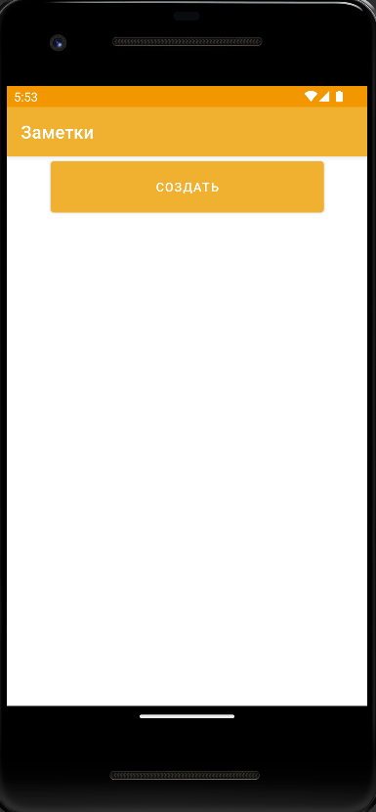

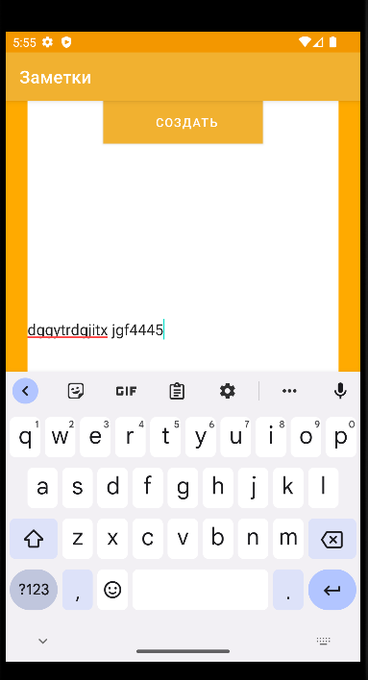

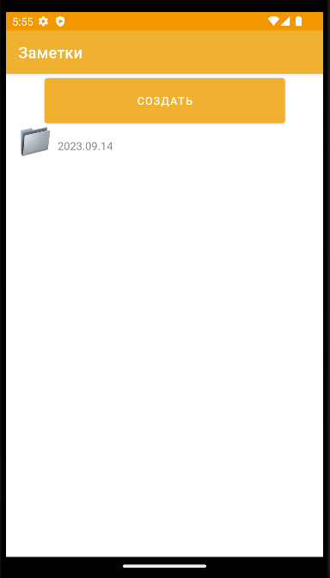

**Ссылка на git:**

[**https://github.com/Sonykapinskya1109/zametki.git**](https://github.com/Sonykapinskya1109/zametki.git)